System Requirement Specifications
HDBuddyPro
SC3040 Advanced Software Engineering
Team Kampong Crew

Document | System Requirement Specifications (SyRS)
Version | 1.0
Date | 21 September 2026
Institution | Nanyang Technological University, College of Computing and Data Science

Table of Contents
1 Table of Contents 2
2 Problem Statement 3
3 Overview 4
3.1 Background 4
3.2 Overall System Description 4
3.3 Users and Stakeholders 5
4 Investigation & Analysis Methodology 6
4.1 System Investigation 6
4.2 Analysis Approach 6
5 Constraints 6
5.1 Dependency on External Data Sources 6
5.2 Data Freshness 6
5.3 Budget and Hosting 6
5.4 Technology Platform 6
5.5 Project Schedule and Team 6
6 Operational Requirements 7
6.1 Availability 7
6.2 User Support 7
6.3 Application Maintenance and Technical Support 7
6.4 Administration 7
6.5 Data Refresh 7
6.6 Backup and Recovery 7
6.7 Logging and Monitoring 8
7 System Capabilities 8
7.1 HDB Flat Information 8
7.2 Location and Environmental Context 8
7.3 Information Presentation 8
8 Input Requirements 8
8.1 User Inputs 8
8.2 External Data Inputs 8
8.3 Configuration Inputs 8
9 Process Requirements 9
9.1 Data Acquisition and Preparation 9
9.2 Data Integration 9
9.3 Error Handling 9
9.4 Performance 9
10 Output Requirements 9
10.1 User-facing Output 9
10.2 Data Attribution 9
10.3 Operational Output 9
11 Hardware Requirements 9
11.1 Client Devices 9
11.2 Server / Hosting Environment 9
11.3 Development and Test Machines 10
12 Software Requirements 10
12.1 Client Software 10
12.2 Build and Runtime Software 10
12.3 Third-party Libraries 10
12.4 Licences 10
13 Communication Requirements 10
13.1 Network Protocols 10
13.2 External Interfaces 10
13.3 Security of Communications 10
14 Installation and Deployment Requirements 11
14.1 Obtaining the System 11
14.2 Frontend Installation and Preview 11
14.3 Server-side Components 11
14.4 Deployment Order and Environments 11
14.5 Release Management 11

Problem Statement
Prospective home buyers in Singapore who are considering an HDB flat must gather information from multiple sources before making a housing decision. Past resale transaction prices, flat attributes, and neighbourhood and environmental information such as dengue cluster activity are published across different platforms and in different formats, requiring buyers to manually cross-reference datasets to obtain a more complete view of a flat and its surroundings.
HDBuddyPro addresses this fragmentation by consolidating relevant public datasets into a single web-based service, enabling users to search, compare and evaluate HDB flats together with relevant neighbourhood information through a unified interface.

Overview

Background
HDBuddyPro is developed by a six-person team as the team project for SC3040 Advanced Software Engineering at Nanyang Technological University. The system draws on Singapore government open data, which is freely available but fragmented across agencies and datasets. The system's value lies in retrieving, combining and presenting that data in a way that supports a housing decision.

Overall System Description
HDBuddyPro is a three-tier web system composed of the following deliverable components:

Component | System-level responsibility
Frontend web application | Browser-based user interface built and served as static web assets; presents search, listing, detail and location-context views to the user.
Backend application server | Central service that receives requests from the frontend, applies business rules, coordinates the data services and returns consolidated results.
HDB data service | Obtains, prepares and serves HDB flat and resale transaction data.
Dengue data service | Obtains, prepares and serves dengue cluster data for location-based risk context.
SNM data service | Obtains, prepares and serves the supplementary location dataset used to enrich flat information.
AI Assistant (Chatbot) | Supplies the language model; its pricing, usage limits and terms of use constrain the system.

Users and Stakeholders

Stakeholder | Interest in the system
Prospective HDB buyers (primary users) | Search and compare HDB flats and view neighbourhood context.
Current HDB owners | Understand recent resale prices in their area.
Project team | Develop, test, release and maintain the system.
Open data providers | Supply the source datasets; their terms of use constrain the system.
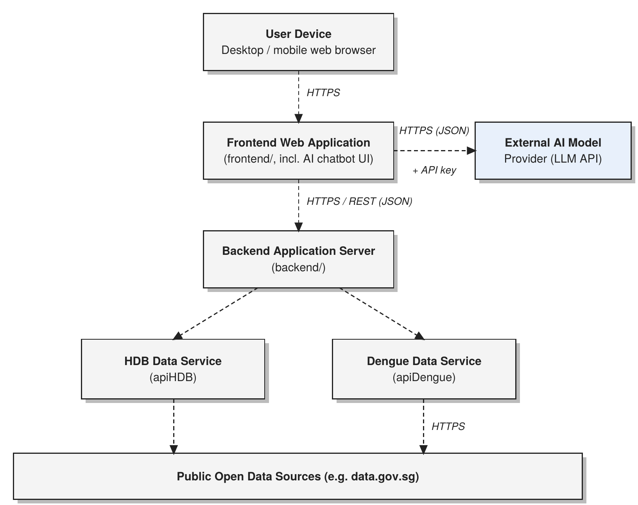

Investigation & Analysis Methodology

System Investigation
Upon evaluation, the team identified several key considerations in the current HDB flat research process and the supporting public data ecosystem. Home buyers often rely on multiple sources to compare flats, while relevant information is distributed across different public datasets with varying formats, update frequencies, access methods, and usage limitations. These differences create challenges in consolidating and presenting accurate information in a consistent and accessible manner. In addition, the team assessed suitable hosting options to ensure that the proposed solution remains feasible within the project’s budget and technical constraints. These findings shaped the system architecture of HDBuddy, leading to a clear separation between the frontend, backend, and dedicated data services for each external data domain.

4.2 Analysis Methodology

4.2.1 Feasibility Study and Requirements Elicitation

The development of HDBuddyPro requires a project team with experience in software development, data processing, user interface design, and system integration. Continuous communication and collaboration among team members are important throughout the development process to ensure that both functional and technical requirements are addressed effectively.

Requirements elicitation focuses on understanding how prospective home buyers currently search for and compare HDB resale flats. Existing property platforms and public housing information sources are studied to identify commonly available functions as well as limitations in the current flat-search process. Particular attention is given to the information users may consider when evaluating a flat, including price, room type, location, remaining lease, proximity to transport facilities and schools, and other surrounding factors.

The team also evaluates publicly available data sources such as Data.gov.sg and OneMap to determine whether the required information can be reliably obtained and integrated into the application. Factors such as API availability, data format, update frequency, request limitations, data completeness, and integration complexity are considered.

A Feasibility and Risk Assessment will be conducted for the proposed features. The assessment will examine technical feasibility, usability, data availability, system performance, implementation complexity, hosting requirements, financial constraints, and dependencies on external APIs. This ensures that the proposed HDBuddyPro features can be implemented within the available project resources while providing a useful and reliable experience for users.

4.2.2 System Analysis and Requirements Specification

4.2.2.1 Perform an Analysis of the Problem Using Object-Oriented Techniques

An external view of the HDBuddyPro system will be developed using Unified Modeling Language (UML). The system model will describe how users interact with the application and how the application communicates with its backend services and external data sources.

The System Requirements Specification will form part of the project documentation and define the functional and non-functional requirements of the system.

Some desired features of HDBuddyPro include:

The ability to view HDB resale flats

The ability to filter flats according to factors such as region, price, room type, and remaining lease

Displaying available flats and relevant information on an interactive map

Displaying important information such as resale prices, remaining lease, nearby schools, MRT stations, and dengue clusters

Retrieving relevant information from public datasets and external APIs

Providing visualisations and summaries to assist users in comparing flats

Allowing users to specify the importance of different housing factors

Ranking suitable flats according to user-defined preferences

Presenting consolidated flat information through a single interface
- AI Chatbot to help users in making a decision

The system will also define appropriate interfaces between the frontend, backend, data-processing services, database, and external data providers.

4.2.2.2 Scope and Limitations

The analysis methodology for HDBuddyPro will involve business analysis, requirement analysis, data analysis, process analysis, and web application architecture analysis.

Business analysis – Identify the purpose of the system, target users, system objectives, external data dependencies, project constraints, available resources, and hosting requirements.

Requirement analysis – Define system inputs and outputs, user requirements, functional requirements, non-functional requirements, system performance requirements, security requirements, and usability requirements.

Data analysis – Examine the collection, validation, storage, processing, integration, manipulation, and retrieval of data obtained from sources such as Data.gov.sg and OneMap. The structure and compatibility of data from different external sources will also be analysed.

Process analysis – Analyse user and system workflows such as searching for flats, applying filters, retrieving external data, calculating proximity to nearby amenities, generating rankings, and displaying results. Data flows and interfaces between different system components will also be examined.

Application architecture – Analyse the overall structure of the web application, including frontend and backend responsibilities, data services, database interactions, external API integration, usability, user interface design, system interactions, and application implementation.

The system is dependent on the availability and accuracy of external public datasets and APIs. Changes to API structures, usage limits, data availability, or update frequencies may therefore affect the information presented by HDBuddyPro. In addition, the personalised ranking feature is intended to assist users in comparing flats according to their selected preferences and should not be treated as a definitive recommendation on which property to purchase.

4.2.3 Object-Oriented Design Using UML

A comprehensive object-oriented design for HDBuddyPro will be developed using Unified Modeling Language (UML) for graphical representation and system documentation. The design will focus on the core functionalities of HDB resale flat discovery, comparison, data retrieval, and personalised ranking.

At its core, users will interact with a web-based interface to search for resale flats, configure search filters, explore locations through an interactive map, review relevant housing information, and compare suitable flats. User requests from the frontend will be processed by the backend, which will communicate with the appropriate internal data services, databases, and external APIs.

The system architecture will separate different responsibilities to improve maintainability and scalability. The frontend will be responsible for presenting information and handling user interactions, while the backend will process requests and coordinate data retrieval. Dedicated data services will handle information obtained from different external data domains, such as HDB resale information and geospatial information.

Additional functionality will include data visualisation, proximity analysis for surrounding amenities, personalised weighting of housing factors, ranking of flats according to user preferences, and an AI chatbot assistant that provides a conversational interface to query, navigate, and interact with the system's search, comparison, and recommendation features seamlessly. Appropriate validation and error-handling mechanisms will also be implemented to manage unavailable, incomplete, or invalid data obtained from external sources.

4.2.3.1 Use Case Diagram

The Use Case Diagram for HDBuddyPro illustrates the interactions between the user and the main functionalities of the application. The primary actor is the home buyer, who interacts with the system to search for HDB resale flats, apply filters, view flat information, explore flats through an interactive map, compare relevant housing factors, specify personal preferences, and obtain personalised rankings.

The system will interact with external data providers to retrieve the information required to support these functions. These interactions will be represented in the use case and supporting system diagrams to provide a clear overview of the relationships between users, HDBuddyPro, and external services.

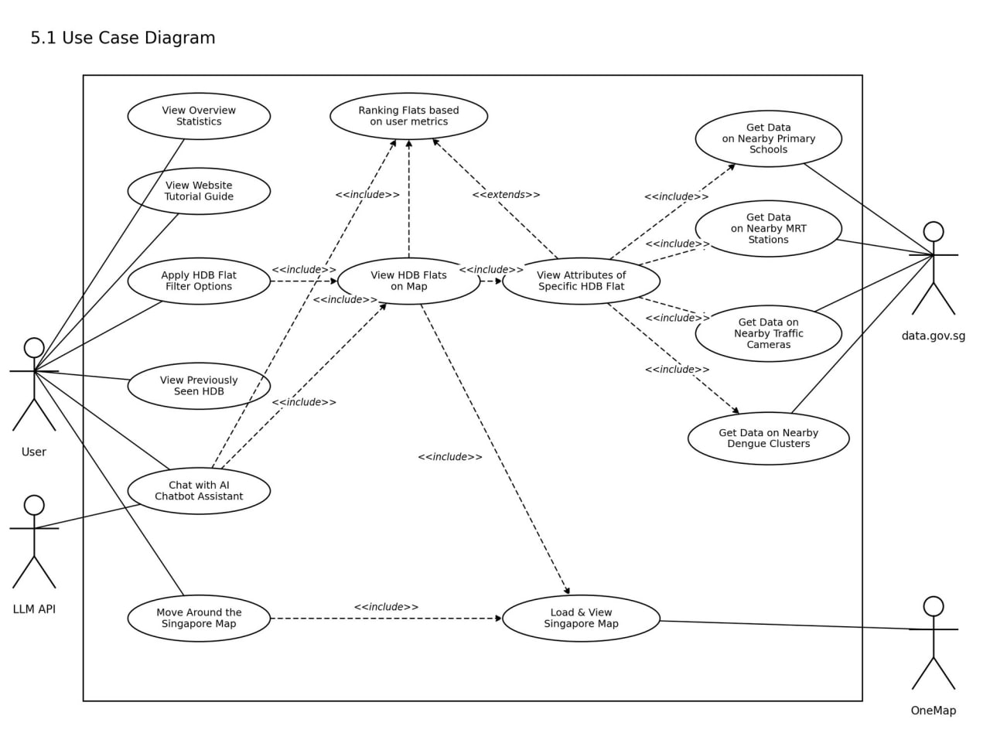

Constraints

Scalability
Scalability is an important consideration in the development of HDBuddyPro, as the application needs to handle potentially large volumes of HDB resale records, geospatial information, and data from multiple external sources. The system architecture separates the browser-based frontend from the backend service layer, allowing data processing tasks such as filtering, proximity calculations, and personalised ranking to be handled independently from the user interface.
The application must also support effective integration with multiple public datasets and APIs. HDBuddyPro uses government data sources such as Data.gov.sg and OneMap to obtain HDB resale information and perform address-to-coordinate conversion for map visualisation. As the volume of data and number of users increase, the backend and data-processing components must remain capable of retrieving, processing, and presenting information efficiently without significantly affecting application responsiveness.

Data Protection
HDBuddyPro does not store any user data on the backend. The application complies with applicable data protection guidelines, including Singapore's Personal Data Protection Act (PDPA), by ensuring no personal data or identifiable user information is collected, stored, or processed on system servers.
Since no personal user information is collected or stored on the backend, risks related to unauthorised access, disclosure, or loss of user data are minimized. Any user interactions or session configurations remain strictly local to the user's client device.
The majority of housing and location information used by HDBuddyPro is obtained from public government data sources. The application ensures that externally sourced data is processed and presented responsibly.

Budget and Hosting
The project has no dedicated budget. The system must be deployable on free or low-cost hosting tiers and must use only free, open-source or freely licensed software and freely accessible data.

Technology Platform
The frontend is built with the Node.js / npm toolchain and must run in current standard web browsers without plug-ins. All components must be buildable using publicly available tools.

Project Schedule and Team
The system must be delivered within the SC3040 semester timeline, by a team of six with the following role.

Team member | Role
Lim Wei Sheng | Project Manager (team leader)
Yun Kar Kit | Frontend Developer
Kee Yu Kai | Backend Developer
Loh Han Meng | QA Manager
Tai Yi Sheng Winston | QA Engineer
Lim Jun Jie | Release Manager

Operational Requirements

6.1 Help Desk Support
Users who encounter technical issues while using HDBuddyPro will be provided with appropriate channels to report problems, such as application errors, unavailable data, map-loading issues, or unexpected system behaviour. Reported issues will be reviewed by the development team and addressed according to their severity and impact on the application.
As HDBuddyPro is developed as an academic project rather than a commercial production service, continuous 24-hour help desk support is outside the current project scope. Support will instead be managed by the project team throughout the development and maintenance period.

6.2 Application Services and Technical Support
The development team will maintain access to the HDBuddyPro source code to perform bug fixes, system maintenance, and feature enhancements when required. The application consists of a React-based frontend, an Express.js and Node.js backend, MongoDB for data storage, and integrations with external services such as Data.gov.sg and OneMap.
Technical issues will be assigned to the relevant team members according to their project responsibilities. The Frontend Developer and Backend Developer will address application-level issues, while the QA Manager and QA Engineer will support defect identification, testing, and verification. The Release Manager will coordinate version management and deployment readiness.

6.3 Administration Features
HDBuddyPro will provide appropriate controls for managing application data and system functionality. Administrative operations that may affect stored application data or system configuration should be restricted to authorised members of the development team.
The current scope of HDBuddyPro primarily focuses on HDB resale flat searching, filtering, map visualisation, personalised ranking, and an AI-powered chatbot. Therefore, complex role-based access control and multiple levels of administrative authority are not part of the current functional scope unless they are introduced during later development.

6.4 System Availability and Routine Backup
HDBuddyPro should be maintained to minimise service disruption and reduce the risk of data loss. The application will separate the frontend from the backend service layer so that data retrieval and processing can be managed independently from the user interface.
The project source code will be maintained using version control, allowing previous versions of the application to be recovered when necessary. The project also includes a Configuration Management Plan specifically covering procedures for managing the project through version control.
Where application data is stored in MongoDB, appropriate backup procedures should be implemented to reduce the impact of accidental data loss or system failure. The system must also account for temporary unavailability of external services such as Data.gov.sg and OneMap, since some HDBuddyPro functionality depends on these external data sources.

6.5 Audit Trail
Where appropriate, HDBuddyPro should maintain system logs to assist with debugging, monitoring, and identifying application errors. Relevant events may include backend errors, unsuccessful external API requests, data-processing failures, and other significant system activities.
These records can assist the development team in identifying when an issue occurred and which application component was involved. As the current HDBuddyPro specification does not define user registration or user-account transactions, a comprehensive user-based audit trail recording who performed every action is not currently required. If user accounts or administrative functions are introduced in future versions, audit logging may be extended to record relevant user activities and timestamps.

System Capabilities
Users can independently search, filter, compare, and evaluate HDB resale flats through the HDBuddyPro web application. The system will provide a browser-based interface that allows users to access housing information from multiple public data sources through a single platform. The application will support the following functionalities:

7.1 Flat Search and Filtering

Search and view HDB resale flats

Filter flats by region

Filter flats by price range

Filter flats by room type

Filter flats by remaining lease

Update or reset selected filter criteria

Display matching flats based on the selected filters

These functions support the project objective of providing an intuitive filtering interface for users searching for suitable HDB resale flats.

7.2 Interactive Map

Display filtered HDB flats on an interactive Singapore map

View the geographical location of available flats

Zoom and navigate around the map

Select individual flat markers

Show or hide selected map information or layers

View nearby amenities and relevant location-based information

The application uses MapLibre GL JS for interactive map rendering and OneMap for address-to-coordinate conversion.

7.3 Flat Information Summary

When a user selects a flat, the system will display a consolidated summary containing relevant housing information, including:

HDB flat address

Resale price

Remaining lease

Distance to the nearest MRT station

Distance to the nearest primary school

Distance to the nearest pre-school

Proximity to dengue clusters

Other relevant information obtained from available public datasets

This reduces the need for users to manually search across multiple government data sources.

7.4 Personalised Flat Ranking

Users will be able to specify the importance of different housing factors according to their personal preferences.

The personalised ranking function will include:

Adjust weighting for proximity to MRT stations

Adjust weighting for proximity to schools

Adjust weighting for proximity to dengue clusters

Calculate ranking scores based on selected preferences

Rank matching flats according to their calculated scores

Display flats that better match the user's selected priorities first

The purpose of this feature is to support comparison rather than provide a definitive recommendation on which property a user should purchase.

7.5 HDB Statistics and Data Visualisation

Users will be able to view visual summaries of HDB resale data to better understand housing trends and differences between areas.

The system will provide:

Regional overview of HDB resale information

Price distribution visualisations

Flat-type distribution visualisations

Box plots

Histograms

Other relevant HDB resale statistics

The project uses ApexCharts to support these visualisations.

7.6 Previously Viewed Flats

Users will be able to revisit flats that they previously viewed during their use of the application. This allows users to return to flats of interest without having to repeat the entire search process.

7.7 AI-Powered Chatbot

Users will be able to interact with an AI-powered chatbot using natural language to obtain relevant information about HDB resale flats.

Users may ask questions relating to:

Flat prices

Remaining lease

Nearby amenities

Differences between flats

Location-related information

Other available HDB housing information

The chatbot will use relevant application data to provide contextual responses and reduce the need for users to manually navigate through different parts of the application.

7.8 Search and Data Validation Assistance

The system will assist users by handling invalid or unavailable requests appropriately. The application should prevent or notify users of conditions such as:

No flats matching the selected filters

Invalid price ranges

Invalid or incomplete search criteria

Missing flat information

External API or dataset temporarily unavailable

Failure to retrieve location or geospatial information

Failure to calculate proximity or ranking information

Appropriate error messages should be displayed so that users understand the issue and can modify their search criteria or retry the request.
Functional Requirements

Input Requirements

User access and search criteria
Users will access HDBuddyPro through a web browser. The system does not require a user to register for an account. Instead, users interact directly with the application by entering or selecting search criteria such as region, price range, room type, and remaining lease. These inputs are used to retrieve and display relevant HDB resale flats that match the user's preferences.

HDB flat information

HDB resale flat information will be made available through the system using data obtained from relevant government data sources. Information presented may include the flat's address, resale price, remaining lease, and proximity to amenities such as MRT stations, primary schools, pre-schools, and dengue clusters. Users can view this information when selecting a flat from the interactive map or search results.

User actions
All user actions will be performed through the HDBuddyPro graphical interface. These actions include applying or changing search filters, selecting flats on the interactive map, viewing flat summaries, adjusting personalised ranking weights, viewing regional statistics, revisiting previously viewed flats, and submitting natural-language questions through the AI-powered chatbot.

Process Requirements
The following are among the process requirements that HDBuddyPro must be able to handle in order to retrieve, process, and present HDB resale flat information effectively.

9.1 Data Retrieval and Processing
The system must be able to retrieve and process information from the relevant data sources required by HDBuddyPro. This includes government datasets obtained through Data.gov.sg and geolocation information obtained through the OneMap API.
The backend service will process requests from the frontend and perform operations such as filtering HDB resale flats, calculating proximity to nearby amenities, and generating personalised ranking scores before returning the results to the user interface.
If an external source is unavailable, the system shall handle the failure without causing the entire application to terminate.

9.2 Data Integrity
The system must maintain the consistency and accuracy of the data used throughout the application. Information obtained from different data sources must be processed and combined correctly before being displayed to users.
HDB resale data, geolocation information, and calculated information such as distances and ranking scores must remain associated with the correct flat throughout data processing. The system should avoid incomplete or inconsistent updates that could result in incorrect information being presented to users.

9.3 Data Validation
Data received from users, external APIs, and stored datasets must be validated before being processed by the system. Invalid or incomplete data should be handled appropriately to prevent unexpected application behaviour.
Validation may include:
- Checking that filtering values are valid
- Ensuring price ranges contain appropriate numerical values
- Validating HDB resale flat records before processing
- Verifying that addresses can be converted into valid geographical coordinates
- Checking that required data is available before proximity or ranking calculations are performed
The system should display appropriate messages where requested information cannot be processed or retrieved.

9.4 Performance
HDBuddyPro should provide a responsive user experience when users search, filter, and explore HDB resale flats. The system architecture separates the browser-based frontend from the backend service layer so that computational operations such as filtering, distance calculations, and ranking can be performed on the server side without unnecessarily affecting the responsiveness of the user interface.
The system should efficiently retrieve and process the required data when users:
- Apply or modify search filters
- Navigate the interactive map
- Select HDB flats for further information
- Adjust personalised ranking preferences
- View HDB statistics and visualisations
- Submit questions through the AI-powered chatbot
User messages should also be displayed where processing cannot be completed successfully.

9.5 Data Repository
HDBuddyPro will use MongoDB as its backend data storage system. The backend is configured to connect to a MongoDB database for storing and retrieving application data.
The system will also use Pandas for reading and manipulating HDB resale-price records and other tabular datasets required by the application.
External information obtained from Data.gov.sg and OneMap will be processed together with the application's stored data where necessary to support flat searching, map visualisation, proximity calculations, statistics, and personalised rankings.

Output Requirements
The following output requirements define how HDBuddyPro will present processed HDB resale flat information, system results, and exceptions to users.

10.1 Search Results and Flat Summary
HDBuddyPro must display the results of a user’s search and filtering actions in a clear and meaningful format. Matching HDB resale flats will be shown through the interactive map and supporting interface based on criteria such as region, price, room type, and remaining lease.
When a user selects a flat, the system will display a consolidated summary containing relevant information such as:
- Address
- Resale price
- Remaining lease
- Distance to the nearest MRT station
- Distance to the nearest primary school
- Distance to the nearest pre-school
- Proximity to dengue clusters
The purpose of this output is to allow users to review important flat information without having to manually consult multiple data sources.

10.2 Exception and Error Messages
HDBuddyPro must provide appropriate output when the system encounters errors, unavailable information, or conditions that prevent a request from being completed normally.
Examples include:
- No HDB flats matching the selected filters
- Invalid or incomplete user input
- Missing flat or location information
- Failure to retrieve information from Data.gov.sg or OneMap
- Failure to obtain geographical coordinates for an address
- Failure to calculate proximity or ranking information
- Temporary unavailability of an external API or dataset
The system should display clear and understandable error messages so that users can identify the issue and, where possible, modify their input or retry the request.

10.3 HDB Reports, Statistics and Summaries
HDBuddyPro must present aggregated HDB resale information in a form that supports comparison and analysis. The system will provide regional overview information and graphical visualisations to help users understand resale-flat data.
Outputs may include:
- Regional HDB resale statistics
- Price distributions
- Flat-type distributions
- Box plots
- Histograms
- Personalised flat rankings
- Comparison of flats based on user-defined preferences
The proposal specifies the use of ApexCharts for displaying flat-type distributions, price distributions, box plots, and other HDB resale statistics.
The personalised ranking output will order flats according to the weights assigned by users to factors such as proximity to schools, MRT stations, and dengue clusters, allowing users to compare available options based on their own priorities.
For your project, I would rename the original headings from “Transaction Summary and Confirmation” and “Registration Reports and Summaries” because HDBuddyPro is not a transaction or registration system. These three headings fit your proposal much better:

Hardware Requirements

Network
Any desktop, laptop, tablet or smartphone capable of running a current standard web browser, with an internet connection. No special hardware is required of users.

11.2 Client Computers
HDBuddyPro can be accessed using standard desktop or laptop computers capable of running a modern web browser.
Supported client environments may include:
- Windows computers
- macOS computers
- Linux-based computers
No specialised hardware is required on the user's device because the main application is browser-based. The client computer should have sufficient memory and processing capability to support interactive map rendering, data visualisations, and normal web application usage.

11.3 Application and Database Server
HDBuddyPro requires a server environment capable of hosting the backend application and supporting communication with the frontend and external services.
The server environment must support:
- Node.js
- Express.js
- MongoDB
- Backend API endpoints
- Data processing operations
- Communication with Data.gov.sg and OneMap
The backend is responsible for handling operations such as filtering, proximity calculations, ranking calculations, and data retrieval so that these processes do not need to be performed entirely on the client device.

11.4 Development and Production Support Systems
The development team will require computers capable of supporting the software development, testing, and deployment of HDBuddyPro.
Development systems should support the technologies used by the project, including:
- React
- Vite
- MapLibre GL JS
- ApexCharts
- Material UI
- Express.js
- Node.js
- MongoDB
- Pandas
These technologies are identified in the proposed HDBuddyPro technical stack.
The production environment should also provide sufficient processing, memory, storage, and network capacity to support the web application, backend services, database operations, and external API communication.

12 Software Requirements
The following software requirements define the operating environment, client software, communication protocols, backend technologies, and third-party software required to develop and operate HDBuddyPro.

12.1 Client Operating Systems
HDBuddyPro is a browser-based web application and can be accessed from common desktop operating systems, including:
- Windows
- macOS
- Linux/UNIX-based operating systems
Since the application is accessed through a web browser, no dedicated client-side installation is required.

12.2 Client Application
Users will access HDBuddyPro through a modern JavaScript-compatible web browser.
Supported browsers may include:
- Google Chrome
- Microsoft Edge
- Mozilla Firefox
- Safari
The client browser must support modern JavaScript and web technologies required by the React-based frontend, interactive MapLibre GL JS map, Material UI components, and ApexCharts visualisations. HDBuddyPro uses React for its user interface together with Vite, MapLibre GL JS, ApexCharts, and Material UI.

12.3 Network System
HDBuddyPro requires standard Internet communication protocols to support communication between the user's browser, backend server, database, and external APIs.
The system will primarily use:
- TCP/IP
- HTTP
- HTTPS
These protocols will support communication between the frontend and backend services as well as external services such as Data.gov.sg and OneMap. The project relies on these external APIs for government datasets and geocoding functionality.

12.4 Backend and Database System
HDBuddyPro will use the following software for its backend and data-processing environment:
- Node.js – server-side JavaScript execution
- Express.js – backend server and API endpoints
- MongoDB – backend data storage
- Pandas – processing HDB resale-price records and other tabular datasets
The backend will manage application requests, process HDB data, perform filtering and ranking operations, and communicate with external APIs.
The original requirement for an IBM Gateway and DB2 database is therefore not applicable to HDBuddyPro.

12.5 Licences and Third-Party Software
HDBuddyPro will make use of several third-party libraries, frameworks, APIs, and development tools. The development team must ensure that these technologies are used in accordance with their respective licensing terms and usage conditions.
Relevant technologies include:
- React
- Vite
- MapLibre GL JS
- ApexCharts
- Material UI
- Express.js
- Node.js
- MongoDB
- Pandas
- Data.gov.sg APIs
- OneMap API
- AI API services
These technologies form part of the proposed HDBuddyPro technical stack.
Any third-party service that requires paid access or usage fees must also remain within the project's allocated budget. The proposal currently provides a budget allocation for AI API.

13 Deployment Requirements
The deployment of HDBuddyPro will consist of a browser-based frontend, a backend application server, a database, and connections to external APIs. The frontend will allow users to access the system through a web browser, while the backend will handle application logic, data processing, filtering, ranking calculations, and communication with MongoDB and external services such as Data.gov.sg and OneMap. This deployment structure ensures that the main system components are clearly separated and can communicate efficiently during system operation.

13.1 Release and Version Management
Deployment activities should follow the project's release and configuration management processes. Source code and application versions should be managed using version control so that changes can be tracked and previous stable versions can be recovered where necessary.
The project plan includes a Configuration Management Plan for managing the project using version control, a Change Management Plan, and a Release Plan defining the features and components included in each software release.
Before deployment, the selected release should undergo the required testing and verification procedures to ensure that the frontend, backend, database, and external API integrations operate correctly.

13.2 Production Environment
The production environment must provide sufficient computing, storage, and network resources to operate HDBuddyPro and support communication between its system components.
At minimum, the production environment should support:
- Hosting of the React/Vite frontend
- Execution of the Node.js and Express.js backend
- Connection to MongoDB
- Internet connectivity for Data.gov.sg and OneMap
- Delivery of the application to users through a web browser

13.3 Continuous Integration and Continuous Deployment (CI/CD)
HDBuddyPro will use a CI/CD pipeline to support consistent building, testing, and deployment of the application. The pipeline will be integrated with the project's version-controlled source code repository so that changes can be automatically validated before deployment.
The CI/CD process should support:
- Installing project dependencies
- Building the React/Vite frontend
- Building and validating the Node.js/Express.js backend
- Running automated tests
- Detecting build or integration failures
- Deploying approved application versions
- Maintaining records of previous releases for rollback when necessary
The CI/CD pipeline should only allow successfully built and tested versions of HDBuddyPro to proceed to deployment. If a build or deployment fails, the development team should be notified so that the issue can be resolved before a new release is made.

